Supervisor:

Georgia Sakellari

Due 18

th

April 2016

**An Investigation into**

**the Effectiveness of**

**Serious Games**

**Using a Healthy Eating App**

**Applied with**

**Decision Trees**

**as an Example**

Word count:

**1**

**3,110**

Product and Developm

ent files:

Uploaded as a zip file

A dissertation submitted in partial fulfilment of the University of Greenwich’s

**Bsc (Hons) Computer Science**

**ABSTRACT**

Serious games are often considered to be potential non-traditional tools for learning, with many proposed benefits to players and professionals alike. This project will investigate the effectiveness of serious games, using a serious game for healthy eating as an example. To further address some of the issues with serious games, this project will attempt to use decision trees to profile users and give them feedback based on game results.

**ACKNOWLEDGEMENTS**

Firstly I would like to thank my supervisors Georgia Sakellari and Mariusz Pelc for their continued support throughout the course of the project. Secondly, my family who are always ready to praise my hard work. Lastly, my partner George who has been my rock throughout my 3 years of university.

# 1 CONTENTS

1 Contents v

2 Introduction 1

2.1 Background 1

2.2 Aims and Objectives 1

2.3 Approach 2

3 Literature Review 3

3.1 Introduction 3

3.2 Artificial Intelligence and its Application in Serious Games 3

3.3 Combating Design, Development and Reliability Issues in Serious Games for Healthcare 4

3.4 Measuring the Effectiveness of Serious Games and Evaluation Techniques 5

3.5 Key Points for Design and Implementation 8

3.6 Conclusion 9

4 Similar Products Review 10

4.1 Introduction 10

4.2 Evaluation Techniques 10

4.3 Cooking Mama Let’s Cook! 10

4.4 Sara Cooking 11

4.5 Lunch Food 12

4.6 Key Points for Product Design and Implementation 12

4.7 Conclusion 13

5 Technology Review 14

5.1 Introduction 14

5.2 Mobile Devices and Platforms 14

5.3 Mobile Devices and Platforms Conclusion 15

5.4 Development Environments and Programming Languages 16

5.5 Development Environments and Programming Languages Conclusion 17

6 Requirements Analysis 18

6.1 Analysis of Requirements 18

6.2 Non-Functional Requirements 18

6.3 Functional Requirements 18

7 Design Documentation 19

7.1 Introduction 19

7.2 Rich Picture 19

7.3 ERD 19

7.4 Use Case 19

7.5 Class Diagram 20

7.6 Decision Tree Diagram 20

7.7 User Interface Designs 20

7.8 Design Documentation Conclusion 20

8 Implementation Discussion 22

8.1 Prototypes 22

8.2 Implementation Issues and Changes 24

8.3 Conclusion 26

9 Legal, Social, Ethical and Professional Issues 27

10 Evaluation 28

10.1 Product Testing 28

10.2 Product Evaluation 28

10.3 Future Scalability 34

10.4 Project Review 35

11 Conclusion 36

12 References 38

Appendix A - Original Project Schedule 41

1 Original schedule 41

2 Revised schedule 43

Appendix B - Similar Product Images and Tables 44

Appendix C - Design Documentation Diagrams .............................................................................. xlvi

Appendix D - Prototype Screen Shots ............................................................................................. xlvi

Appendix E - Evaluation Tables ............................................................................................................ l

Appendix F - Bibliography ................................................................................................................. liii

Appendix G - Prototype Screen Shots ............................................................................................... liv

# 2 INTRODUCTION

This project will document the investigative processes used to gather information on serious games, demonstrating how each section is linked, and how this is used to create a final product that accomplishes the initial goal. There are three sections which cover literature, similar products and technologies, each chapter takes into account pre-existing published documents, similar applications and technologies which will be used to design and develop the final prototype. Following on from this will be a detailed analysis of the product requirements and design documentation to diagrammatically show the evolution of the product, subsequently the next section will discuss the implementation of the product and what may have changed from initial ideas. Lastly, the evaluation and conclusion will explore the project as a whole, using evaluation techniques mentioned later in the report to assess the data and learning outcomes of this project.

## 2.1 Background

Serious games have become increasingly popular among the video game industry and academics alike, these games tend to focus on engaging, teaching and changing the behaviour of players. Although there is no explicit definition for the term serious game, there is general agreement among developers and academic researchers that serious games are games used for purposes other than entertainment alone that being for educating and training players. The effectiveness of serious games is commonly called into question as there is very little evidence to support its claim, this project will attempt to gather some of this evidence as well as its own and give insight into whether these claims are justified.

## 2.2 Aims and Objectives

This project will explore what enables a serious game to impact its users both positively and negatively, the issues that commonly arise during the design, implementation and use of a serious games and how the information gathered from these academic sources can be used to create a serious game that can improve the physical health of its players by changing the attitudes and behaviour of users in regards to food. As a result of a severe lack of empirical evidence to determine that serious games are just as effective as traditional learning methods, this project will also attempt to ascertain the effectiveness of serious games and whether the application of decision trees can be used improve on that.

## 2.3 Approach

There were many obstacles which made it difficult to complete this project using a structured methodology. However, the waterfall methodology encompassed the structured development that aligned perfectly with this type of project. As the project is broken down into several iterations, it was much easier to follow in a very basic but structured way. Prototyping was also major part of this project and allowed for rapid deployment of functional products. Although the RAD (Rapid Application Development) methodology is an alternative to the waterfall method, it tied in well with this project as there were three prototypes that ended with the final design. It was extremely difficult to follow the schedule made earlier in the year, along with the project proposal. Due to mismanagement with time, other deadlines and underestimations on the lengths of time some of the iterations would take, the schedule became more of an initial idea as opposed to something which aided in the completion of the project as a whole.

# 3 LITERATURE REVIEW

## 3.1 Introduction

There are many opinions on whether serious games are effective for learning and changing behaviour. Serious Games are currently used as tools to educate and train players on important topics, these tools are delivered in a medium which is more inviting to players. The aim of this literature review is to find related articles of work that have been produced in the field of Serious Games for healthy eating, using these to better understand the problems faced in these fields and the aspects of Serious Games that make them effective. The information gathered in this review will be evaluated in order to identify the benefits and weaknesses of Serious Games and used to implement a product which meets the requirements and standards of a Serious Game application for healthy eating.

## 3.2 Artificial Intelligence and its Application in Serious Games

In entertainment games, Artificial Intelligence is used to give non-player characters the impression of intelligent behaviour, (Kehoe, 2009) describes it as more artificial than intelligent because the behaviour is merely simulated. This AI can be used to create a set of rules which the environment is bound by and even create a more realistic gameplay experience for players. Similarly, Serious Games use AI as rules for the basis of the game and to enhance the realism of the simulated experience. According to Aldrich (2009, p.174), AI helps to create behaviours in non-player characters that give the impression of unpredictability. This can also be applied to other aspects of a game, such as randomised events which make an environment simulate realism. Artificial Intelligence techniques can help personalise a game; making the experience more player specific. If a game were to be optimised for a specific player, it can be assumed that the player has been conceptualised (Brisson et al., 2012), how these ideas are determined is where artificial intelligence plays a significant role.

#### Fuzzy Logic

Johnson & Wiles (2001) describe Fuzzy Logic as a superset of Boolean Logic which not only includes true and false, but partial truths. To illustrate, an ambiguous term such as “quite warm” can be represented using Fuzzy Logic techniques. There are several benefits to using fuzzy logic in games; firstly its simplicity allows developers to quickly incorporate AI into their games, secondly the nature of the logic allows it to be used in the same way as expert systems. This means that an expert in a field domain would have the ability to formulate rules for a system and the fuzzy system can be used to emulate the experts reasoning (Catalano, Luccini, & Mortara, 2014). As previously mentioned, because the implementation would be relatively simple in contrast to other AI techniques which would require a far deeper knowledge than that of a game designer. (Catalano, Luccini & Mortara 2014) suggest that fuzzy logic is used in cohesion with other AI techniques, namely; fuzzy systems, fuzzy control and even fuzzy decision trees. Clearly fuzzy logic has many properties which makes it a desirable AI concept to implement into games, due to the way it can be combined with other AI techniques means it can be manipulated and developed to create very complex, but highly effective games and other media.

#### Decision Trees

Decision trees depicts rules for dividing data into classes, each rule splits the data and so on until all data reaches a final group (Neville, 1999). Neville goes on to say that simple decision trees are appealing because a few inputs can be put into a target group, he also states that decision trees can use differing variable types; nominal, interval and ordinal. This feature can be likened to fuzzy logic which can also account for non-linear inputs. (Tsang, Kao, Yip, Ho, & Lee n.d.) also notes the appeal of decision trees; explain they are easy to read, practical and rules can be easily extracted. (Neville 1999) also states that although simple decision trees can be useful they can also be too simplistic to cover the target groups for the pieces of data.

## 3.3 Combating Design, Development and Reliability Issues in Serious Games for Healthcare

When developing a serious game that specifically involves the health of it users, it is important for developers to understand that these types of games are not to be used as a replacement for physicians or other qualified professionals, instead these games should facilitate experts into doing better in their field (Michael & Chen, 2006, p.197). Another development issue is aiming to deliver a final product which does not make the initial problem it tries to solve worse or add more problems. Michael and Chen go on to speak about accessibility issues that some users may have, stating that it cannot be assumed that every user will have the use or their eyes, ears or two hands. When creating a serious game for users with some type of disability or impairment, it is important to look at different techniques of interaction for those users; for example, virtual reality headgear.

According to (de Freitas & Liarokapis 2011, p.9) due to the global use of the internet, and a need to create engaging ways to learn in education, serious games has become a new form of education and training. This is in agreement with (Michael & Chen 2006, p.200), who point out that, with the internet serious games give educators an important opportunity. An entertainment game that consists of real life processes does not have to show accuracy, on the other hand, a serious game with real life simulations may place a lot of importance into its realism and accuracy (Michael & Chen, 2006, p.29). (Forshay, 2014, p.5) explains that finding a balance between the game and the simulation can be a difficult task, as if the fun aspects are too entertaining they can distract the player from the educational learning experiences. Feedback to the player during the game is very important to the learning experience (Forshay, 2014, p.6) states, the player can see behavioural changes when they interact with objects in the environment; this is a form of feedback. Another way, is conveying actual messages which give the player some kind of information on performance, whether that is messages via nonplayer characters or by score boards. Similarly, (Boller, 2014) stressed the importance of providing feedback and levels/stages so the learner can see whether they are progressing or succeeding in the game.

(Catalano, Luccini, & Mortara 2014) argue that providing a suitable learning environment coupled with useful interactions, can lead to an immersive environment which is relevant to the purpose of the game. On the other hand, the opposite can be applied to a game with an environment and interactions that are not relevant to the model and learning outcomes of the game. Keeping in mind the type of game that is being developed is key to ensuring learners are immerged in a world that holds relevance to what they are attempting to achieve.

As there has been very little research done into how effective serious games are, healthcare professionals are undereducated about serious games and their effectiveness. These professionals have to judge the safety and usefulness of such an application, ensuring that both themselves and the patient are informed on the purpose of the serious game and whether its claim of effectiveness can be trusted (Graafland et al., 2014, p.2).

## 3.4 Measuring the Effectiveness of Serious Games and Evaluation Techniques

Over recent years the effectiveness of serious games has been debated among professionals and developers alike. (Guillén-Nieto and Aleson-Carbonell 2012) states that although there are undeniable potential benefits to using video games as a tool for learning, there is very little agreement on what features will support the effectiveness of learning. (Graafland et al. 2014) reinforces this idea, explaining that the usefulness of serious games; specifically in the field of healthcare is often unclear. (Thompson 2012) describes the field of serious games for health as being in its “infancy”, the general consensus being that serious games have the potential to become useful and effective tools for learning, although that potential is yet to be fully demonstrated. On the other hand, (Clark R., et al 2010) claims that there is no evidence to suggest that serious games are any more affective then other types of learning approaches. In agreement, (Girard, Ecalle and Magnan 2013) speak of the lack of clear empirical evidence to support the effectiveness of serious games.

As the usefulness of serious games remains under question, Girard, Ecalle and Magnan (2013) carried out an analysis of results that aims to find empirical evidence of effectiveness and acceptability of serious games. In an attempt to make a comparison between serious games and video games, Girard C, Ecalle & Magnan selected thirty articles that used terms such as; “video game”, “serious game”, “game based-learning” and “training”. To narrow down the publications which were to be used, specific criteria which categorised both serious and video games was used, basing this on theoretical articles by other authors. The data was then analysed by several determining factors; number of subjects in the control group and characteristics of each subject, pre-test and post-test questionnaires or cognitive tests, the length of time the games were used, game type (video or serious game) and lastly whether these games had a positive effect, negative effect or no effect at all. To conclude their findings, after examining the gathered results (Girard et al., 2013) determined that, a majority of the games resulted in no improvement of the knowledge and skills acquisition compared with traditional teaching methods. Although, they agree based on the effect on the engagement that serious games maybe a useful learning tool, as it stands there is a substantial lack of evidence which needs to be addressed before conclusions can be made about the effectiveness of serious games.

There are many flaws in the approach to gathering data for analysis and using this data to determine certain factors; such as the engagement of the game. Firstly, bias is a major concern when secondary research is undertaken in an uncontrolled manner, especially when the data examined is on such a small and narrow scale. Secondly, the comparison between serious games and video games can be recognised as negligible, because of the complete lack of purpose that a video game has outside of fun. The key differences between serious games and video games is that the latter is often described as “entertainment” (Breuer and Bente 2010; Thompson 2012). This clearly means there is no real attempt to teach the player about important topics that are relevant outside of the game world. Perhaps a comparison between serious games and the traditional learning environments could have been a better way of determining how well these games measure up to the standard of learning and changing the behaviour of subjects. One of the greatest downfalls of this research is that the effectiveness of each serious game is not measured by very specific, empirical standards. For example, if a serious game excels in keeping users engaged, but fails to reinforce knowledge acquisition in the long term, does that make the serious game a failure? There is no way to form an opinion on the effectiveness of a serious game based mainly on the answer to one poorly formulated question. This idea is supported by (Mitgutsch & Alvarado 2013) who explain that their process of serious game assessment starts by investigating the purpose of the games impact on players, and that each designer has very explicit goals when creating a game for a specific purpose. In regards to investigating the purpose of the serious game first, it seems to give a much better understanding and general scope of what is trying to be accomplished, leading to a more accurate analysis of the results found.

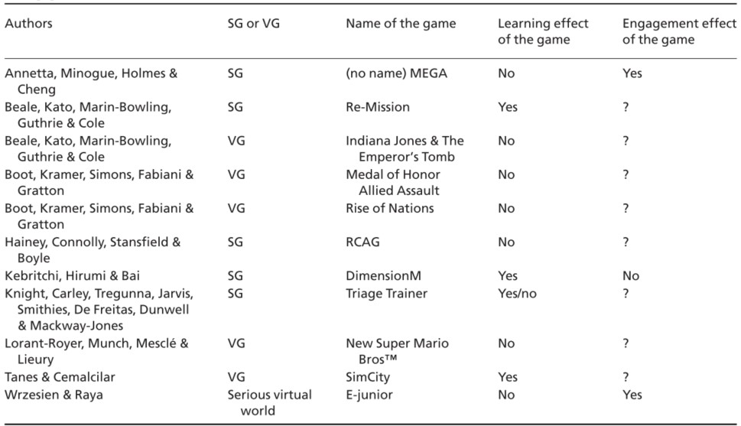

Analysis table depicting evidence of the effectiveness of serious games and video games (Girard, Ecalle and Magnan 2013)

(de Freitas and Oliver 2006) proposed a four-dimensional framework which would be used to evaluate game and simulation based educational games. Each dimension is described as; firstly the context of the game or simulation, where does the learning/play take place and what resources are accessible. The second dimension centres on the learner, for instance; age, learning preferences and background in education. The third dimension covers the diegesis; that is the plot or story of the game in relation to its interactivity and immersion. (de Freitas and Oliver 2006) goes on to mention that this dimension highlights key differences of immersion whilst in the game and the critical evaluation that takes place outside of the game by the user. This point coincides with that of (Boller, 2014; Forshay, 2014, p.6) who point out the need for consistent feedback so learning outcomes can be strengthened. Lastly the fourth dimension covers the process of learning in a formal structure-based learning environment and during informal times of learning.

Serious games are made to not only educate players, but change the behaviour of that player. When discussing the effectiveness of a serious game, it is important to question whether the game worked as intended. According to (Thompson, 2012) on social cognitive theory, the key way to learn new behaviour is to perform it successfully alone, this is described as personal mastery. Thompson goes on to explain that setting performance specific feedback, allows the user to self-monitor; in-turn facilitating the process of behavioural change.

## 3.5 Key Points for Design and Implementation

The learning outcomes of this application must be clearly stated to users to ensure; the safety and trust of the user. The proposed product should help users self-monitor their diet in a fun and undemanding way. This approach will encounter less ethical and professional implications, than a user who would play in conjunction with regular visits to a nutritionist or dietitian. The realism of this game holds great importance in teaching users to understanding how to positively impact their diet, it is imperative that the any imagery or simulations are accurate and take precedence over the “fun factor”, otherwise there could be a likelihood of giving and perpetuating misinformation. One issue that should be avoided is making a problem the application is trying to solve worse or adding to that problem. The grading system will allow users to see progression and understanding, which is a key factor for a serious game which sole purpose is to change the behaviour of its user. This game is not just about educating users, it is about changing the behaviour and attitudes of those users.

Giving the user control over this application may help to create a sense of fun, independence and familiarity. This could affect the way the player interacts with the game, allowing them to express themselves more honestly therefore providing better data accuracy in regards to the games evaluation. As Serious Games effectiveness are yet to be proven many methods have been proposed as ways to evaluate them to ensure correct analysis. Based on this, it seems optimal that a hybrid method which encompasses the main points and outcomes of an effective evaluation tool will give the most accurate results, as some of the criteria are not necessarily well suited to the proposed application. These evaluation tools would be the four-dimensional framework proposed by de Freitas & Oliver and the Likert Scale for evaluating user opinions. Mitgutsch & Alvarado reinforce the point that to assess a serious game the purpose must be clearly determined.

A decision is likely to be easier to design and implement based on the type of serious game that is proposed. Although fuzzy logic offers a broader way of interpreting information, it does not offer the same ease of use that decision trees does whilst giving similar results.

* An application which is “too fun” may distract the user making it difficult for them to remember the point of the tasks and learning outcomes as a whole
* A lack of feedback will leave users confused and demotivated to continue playing the game, focus on giving regular detailed feedback to users
* The games purpose must be made clear to players with outcomes detailed succinctly

## 3.6 Conclusion

As the gaming industry continues to expand, serious games will allows be a potential medium for nontraditional learning methods. Looking closely at some of the issues that make the design and development of serious games so difficult helps to look at the situation as a larger whole. The effectiveness of game-based learning has been put into question overall several years, as there is still a severe lack of evidence to find a clear answer to this question. As stated by many academic researchers, a serious game must be developed to the highest possible standards otherwise it may be difficult to tell whether the medium or the games design is at fault. Following the standards mentioned by Michael and Chen would surely benefit any developers to not only develop a well-made serious game which is fit for purpose, but actually benefit its player base.

When attempting to determine what may be hindering the effectiveness of a product, the processes of evaluation must be taken into consideration. As shown many other factors can compromise the accuracy of the results such as; control group bias or evaluating serious games with entertainment games, when traditional evaluation methods would prove to be more effective as a benchmark for comparison.

AI techniques have clearly become a large part of video games today and their core functions, with these types of technologies used in serious games there are many ways to enhance user experiences in terms of fun and learning. As decision trees have the ability to become extremely complex from even the most simplistic of trees, the scalability can easily been seen.

# 4 SIMILAR PRODUCTS REVIEW

## 4.1 Introduction

This review will detail products which have a similar concept or outcome to the proposed project. Each of these products will then be evaluated then information derived from the analysis will be used to enhance the design and development stages of the proposed project. The products listed are much more sophisticated in terms of visual gameplay, but the basic concept which is to create a meal is identical to the proposed application. For images of each application and a comparison table please see appendix B.

## 4.2 Evaluation Techniques

It is important to question what evaluation technique will be suitable to test the similar products. It can be considered difficult because the products found do not exclusively hold the title of serious game but some have educational properties, this will definitely affect the way the app will be evaluated and the outcomes of the evaluations in regards to a comparison between them and the proposed product. I will attempt to evaluate the game from two perspectives; as an end user and from the four dimensional framework proposed by

## 4.3 Cooking Mama Let’s Cook!

#### 4.3.1 Overview

Cooking Mama is a 3d game mobile application which allows users to create virtual dishes using preset recipes. Although this app is mainly for entertainment it is also listed as educational, because the game uses real life recipes. Cooking Mama enables users to prepare and cook a variety of meals from a set of recipes, these recipes are not specific to healthy eating. As a result, it is clear that the educational value of this game is limited to learning recipes as opposed to healthy eating. It can also be argued that due to the realism of the preparation and cooking sequences that this game also teaches players to cook.

#### 4.3.2 Appearance

Cooking Mama uses 3d computer graphics to create a very realistic simulation of a kitchen environment. There is great detail given to different aspects of this environment including the textures of the food, to the realistic movements used during preparation time. This application seems to be aimed at children due to the usage of very bright colours, in spite of this each screen is cohesive with the overall design of the application. The games interactions are easy to understand even for an inexperienced user, menu options are clearly labelled with plenty of prompts if a user were to have any difficulties. However, the game seems to be cluttered which can be distracting or frustrating for a user who prefers simpler layouts.

#### 4.3.3 Usability

The application is compatible with Android platforms above 4.0.3 for smartphone and tablet devices, although the developers cannot guarantee that the game will work on every device that meets the required criteria. The app seems to cover basic needs for accessibility, but lacks extra functionality for users with physical impairments. This application uses prompts and feedback to help users understand the game whilst they play it, this dramatically shortens the time at which a user would have to spend learning to navigate and play the game. Although this game gives many prompts it allows users to learn by playing through the game on their own, and gaining an understanding by completing without prompts. Cooking Mama also supports a large range of languages which greatly enhances the games features, because users can play the game in their first language. Although there are many positives to this application, I feel the user interface is extremely cluttered and would raise usability and accessibility issues for users who may have some type of impairment.

## 4.4 Sara Cooking

#### 4.4.1 Overview

A 2d cooking game aimed at children which allows players to pick a recipe and go through the processes of preparation and cooking. It has a more simplistic style in comparison to other simulators, as there is no way to stray from the recipe in question. All preparation and cooking times are fixed so the simulation is not very accurate e.g. leaving food in the oven for a longer duration than allotted does not make the food burn. This app has the characteristics of a game made purely for entertainment, although the recipes can be used in real life the simulations used within the game are not suitable for learning about cooking because they are poorly detailed and teach nothing about healthy eating.

#### 4.4.2 Appearance

The games uses one interactive scene to gather ingredients and prepare meals. The colours used in the user interface are very consistent throughout the gameplay. The 2d graphics are simple but they do give a sense of realism to users.

#### 4.4.3 Usability

There is a distinct lack of feedback which can adversely affect a user’s motivation to play the game. To illustrate, users with impairments may find it difficult to understand how to use the game or whether they are making any progress within it.

## 4.5 Lunch Food

#### 4.5.1 Overview

This game closely resembles the proposed product, using simple gameplay techniques to achieve the desired effect of a food preparation game. The player can select a lunchtime meal to prepare with basic visual guidelines to follow. There are two ways to prepare meals in this game; a simple tap selection method which merges game components and more complex interactive gestures. The games purpose is purely entertainment as it provides no real educational value, unless the user were to follow some of the visual recipes in real life of their own accord. There is no progression in the game, nor is there any type of grading feedback so users can gain achievements.

#### 4.5.2 Appearance

This app is a 2d selection based game that uses images of real food to add to user experience, this is coupled well with the engaging colours. Although the game has little prompts for the user the simple layout makes it easy to understand how the game is played.

#### 4.5.3 Usability

There are very little prompts to follow whilst playing the game, and a distinct lack of feedback for players after the games completion. The simplicity of the game allows users to take a more exploratory approach when playing, giving a higher sense of achievement on the games completion.

## 4.6 Key Points for Product Design and Implementation

Bright colours may be more interesting to users, keeping their attention over longer periods as it seems to be a running theme amongst the similar products. As well as a common use of colours, using feedback and prompts can not only help users to understand how to interact with the application but encourage learning and player progression. The simplicity of Lunch Box is something that can be easily translated to the proposed product, as it is important the gameplay isn’t over-engaging to the user; allowing them to keep the learning outcomes in mind. I will attempt to combine the simplicity of “Lunch Food” into my gameplay, in addition I will attempt to add feedback to enhance the users experience throughout the application.

## 4.7 Conclusion

All three of these games have only one commonality between them; each game simulates food preparation to some degree. Although two of the three games makes no real educational claims, it could be argued that a food preparation/cooking simulator will inevitably have some effect on user in regards to cooking. Without a specific purpose though, the apps are just entertainment with the addition of some educational extras. I felt the strongest game was “Cooking Mama” for the following reasons; frequent user feedback which allows user to see their own progression, detailed and accurate simulations of cooking which gives users a sense of realism and familiarity and lastly, a simple enough to use interface for users albeit cluttered. I would say the weakest of the apps is “Sara Cooking” which is distinctly lacking useful feedback, which makes the game very difficult to play as the user does not have many ways to tell whether they are progressing in the game. As previously mentioned there is no feedback in the app “Lunch Food”, I did not feel that this was the weakest application because its redeeming factor was a very easy to use interface that simply allows the user to tap the button and add the piece of food to the plate. “Sara Cooking” seemed to be masquerading as simplistic version of “Cooking Mama” because it attempted detailed food simulation and sharing real recipes, whereas Lunch Food used its simplicity to create something that was just for entertainment purposes, without any added features.

# 5 TECHNOLOGY REVIEW

## 5.1 Introduction

This technology review will investigate which mobile devices and platforms are the most suitable to support this project. Accordingly, the development environment and programming languages will also be investigated to determine the appropriate software development tool that will be used. Consequently, the aforementioned findings will aid in the design documentation and the development and implementation of the prototype product.

## 5.2 Mobile Devices and Platforms

Mobile devices have become an everyday part of society’s daily operation, with each technological advancement the capabilities of such devices continues to grow. It can be argued that because of such high accessibility to smart devices, these can be used to dramatically boost learning and training. There are several widely used types of mobile devices, smart phones, smart watches, tablets etc. Approximately 1.91 billion people are smartphone owners (emarketer, 2014), and around 1 billion are tablet owners (emarketer, 2015). Due to the accessibility and affordability of such devices, it seems logical to create the application on a smartphone device with touch screen capabilities because of the nature of the application.

**Android** is a mobile OS currently made by Google which is mainly used on touch screen devices. This OS is supported by many smartphone devices and because Android is open source developers and users are free to customise the OS to suit their needs. Mainly android applications are developed using Java, if however Android NDK is being used C# and C++ are also available.

**iOS** is another mobile OS currently under Apple which made specifically for Apple devices. iOS is not an open source OS, so does not allow for as much customisation as Android, although there have been improvements to these restrictions over time. For developers Apple has a development environment called Xcode which uses Objective C, Swift and iOS SDK are also viable options to create apps for Apple devices.

|  |  |  |  |
| --- | --- | --- | --- |
|  | Open-Source | Free deployment | Open Platform |
| Android | Yes | Yes | Yes |
| iOS | No | No | No |

As seen above, there are two main platforms which possess different options in terms of functionality, but because of the type of game being produced, usability and user friendliness of the device holds the utmost importance. The application for this project is meant to be a tool that many people can access and use with their own devices, when creating serious games developers must assume that some of the users of the application may be even temporarily disabled or suffer some type of impairment (Michael and Chen, 2006, p.201). Unlike other mobile operating systems Android can be highly customised by users, there are apps that can be used in conjunction with other apps to create an even friendlier usage environment. iOS lacks the customisability and usability which would help users personalise their experience with their mobile device. Another factor to take into consideration is the costs to the developer, Android has no subscription or fee for having an app in their store, whereas Apple has some type of fee basis. Many academic researchers and developers in the field of serious games, highlight the importance of keeping development cost effective (de Freitas et al., 2011; Clark et al., 2010; Gloria, Bellotti, & Berta, 2014). According to International Data Corporation (2015) Android made up 82.8% of total smartphone units sold in 2015. Android covers usability, cost efficiency and global usage as a platform, therefore seems the best option to create a serious game.

## 5.3 Mobile Devices and Platforms Conclusion

After looking at some of the key differences between two of the most used platforms, it is apparent that features such as cameras, microphones or GPS will not affect the application because they have little to no impact in terms of the functionality of the app. As a result, the more technical features of each platform where not discussed, rather usability and customisability which is directly related to the user, were major factors in choosing the most suitable OS. As mentioned previously in the literature review reducing costs associated with developing serious games is extremely useful to the developers themselves, mostly because the budget for creating these types of games is very tight. Overall there are many ways for users to customise their smart phone experience and this aids users with impairments to do the same, with screen readers for the visually impaired and touch screen sensitivity adjustment apps that go beyond a smartphones normal setting, there are many ways for everyone to access and play using android devices. Clearly Android offers the most to developers and users alike in regards to; affordability, usability and customisability.

## 5.4 Development Environments and Programming Languages

As a result of the rise in app development over the years, there are many game engines which create games not only for consoles and personal computers but for smartphones and tablets alike. During the decision making process these key points must be addressed; the chosen IDE must support android development, intuitive GUI, cost-effectiveness, widely known programming languages (preferably no in-house languages), relatively user friendly and lastly have 2d development capabilities. After careful consideration, and the fact that Java is mainly the language used to create applications for android; it seemed necessary to a consider IDE’s which are not specifically designed for game development.

Considering each of the previously mentioned factors, the list of suitable IDE’s have been narrowed down to; Unity 3D, Cocos2Dx, Corona SDK and Android Studio.

**Unity3D** is a 2D and 3D development environment which is used to create games for various platforms, like consoles, PCs and smartphones. Unity uses 3 scripting languages; C#, JavaScript and Boo. All of these scripts can be used in one project which allows for greater collaboration between developers of different coding backgrounds. In regards to performance because of the scripts being used, the code should compile quickly in comparison to compiled languages.

**Cocos2Dx** is a 2D open source game engine which primarily focuses on cross platform development for mobile devices. Cocos2Dx supported languages are; C++, Objective C, Java, JavaScript, C# and Ruby. As there are different versions of this engine, C++ is consistently maintained and supports the most platforms.

**Corona SDK** is a software development kit, with more specialised development aimed toward mobile devices. This development kit includes many third-party tools which help developers during the implantation processes. Corona SDK uses a scripting language called Lua layered with C and C++. **Android Studio** is the official IDE for developing on android platforms, because of this it boasts many capabilities which allows developers to benefit from platform specific functionalities. Android Studio makes it easy to code and build apps quickly using its Gradle-based system, enabling you to quickly test your app as you code it. As well as quick building, it has an easy to use drag and drop feature which can also be coded manually using XML (Extensible Markup Language).

## 5.5 Development Environments and Programming Languages Conclusion

All of the previously mentioned development tools could add incredible value to a project at this level. Although it would seem that in terms of rapid prototyping, 2d capabilities and overall efficiency Unity 3D has the most options available to a developer working on a project alone with a very short development time, it is arguably a much safer to use Android Studio because of its consistency in language type, ease of use and lastly it’s android platform specific design. Clearly Android studio cannot rival the 2d features that Unity 3D has to offer, however it does make the processes of development far easier in comparison to a game engine which makes it very difficult to manipulate auto-generated code, which would require a wealth of knowledge and experience to do so. For these reasons, the proposed product will be developed in Android Studio.

# 6 REQUIREMENTS ANALYSIS

## 6.1 Analysis of Requirements

During the process of writing the literature review, I found very useful information on how to avoid making common mistakes when developing serious games. It was this that allowed me to look how to go about the stages of designing and implementing the product. There are some very specific things that have been added to the list of functionality to address usability, efficiency and reliability.

To develop a clear understanding of what is required to make this product effective, I will use the MoSCoW Method to determine what should be a part of my functional and non-functional requirements and in what order of priority each will take. This method uses a must have, should have, could have and won’t have methodology and then prioritises each of the requirements so the most important are delivered first for the most immediate benefits.

## 6.2 Non-Functional Requirements

#### 6.2.1 Could Have

Collect data from user’s contribution to community forum

Issue “ranks” to user’s based on gathered data

Check the frequency at which a user uses the app measured by duration and access times

## 6.3 Functional Requirements

#### 6.3.1 Must Have

Must be deployable on android touch screen devices

Interaction type must be optimised for touch mechanism

Collect data from users in game activity

#### 6.3.2 Should Have

User will be able to register with username, email and password

User will be able to authenticate using username and password

# 7 DESIGN DOCUMENTATION

## 7.1 Introduction

In order to gain a better understanding of the processes needed to develop the proposed product, a variety of documentation was needed to help visualise the products functionality. I felt the following diagrams were well suited to the project in question; entity relationship diagram, rich picture, class diagram and a use case diagram. Each of these diagrams uniquely define specific aspects of the application, its basic function and how they combine to make the final product.

## 7.2 Rich Picture

A rich picture is a combination of images symbols and text which summarises specific issues and situations. It allows developers to conceptualise the problem they are attempting to fix. Although my rich picture is simple, I feel it is an accurate representation of the problem domain and how my application attempts to fix these issues.

## 7.3 ERD

I wanted to implement a database in MySQL that allowed users to create a profile with the app, save game recipe data like the name and grade and lastly scores and ranks based on game data. This design was not implemented into my final product because I felt that it was not an integral part of the serious games function and due to time constraints. This is quite a simple ERD which was far more complex in my initial designs. I opted not to display it because in the products current state, it would be difficult to relate such a complex schema to such a simplified application.

## 7.4 Use Case

The diagram below shows how a user can transition between use cases, and which parts of the application should be inaccessible without first accessing or completing other use cases. Each stage must be fully completed to get to the next stage, this ensures that users are accessing every aspect of the game and allows them to gain the most detailed feedback possible.

## 7.5 Class Diagram

I wanted the class diagram to encapsulate in its most simple form what I wanted to achieve. I kept in mind my programming skill level, programming knowledge and problem solving skills. These factors would greatly affect the outcome of the product so I wanted to represent the app in a basic way, in addition to keeping the classes in cohesion with the use case diagram and ERD.

## 7.6 Decision Tree Diagram

The decision tree is the only means by which users can receive feedback on each section of the game as a whole. I wanted to implement something clean and simple which put users into distinct classes. I used simple techniques to create a diagram of a decision tree for feedback. Keeping in mind what was stated by Neville (1999), who explains that using decision trees can be optimal because they can use different data types, I created a decision tree which has four pieces of input data to get to specific target group. At first I found it to be complicated because of the various outcomes that were possible from such a small amount of inputs, however I later came to realise that this is the exact purpose of the decision tree; to give you a wide variety of classes for your data sets. This allows for a greater breakdown of information which can be used for testing and evaluation.

## 7.7 User Interface Designs

This storyboard will roughly detail how the application will appear to users. Omitting colour and unnecessary text makes it clean and simple to understand, leaving the basic layout and purpose to be clearly seen. As the proposed product is an app, it seemed appropriate to choose a type of diagram which will visually show a user’s interaction with it. According to W3C (2010), “the key aspect to usability is a User Centred Design (UCD)”, in an attempt to keep the design simple yet appealing I tried to maintain the balance between user-centred and necessary functionality.

## 7.8 Design Documentation Conclusion

I felt that every piece of design documentation was pivotal in the outcome of the product, as a visual tool they gave me to opportunity to look at the proposed product from the external to the internal workings. The rich picture allowed me to show my own knowledge of the problem in question and how I intended to tackle those issues, this then enable me to create other documentation that I felt would visualise how each part of the app would combat those problems. In hindsight I felt that the class diagram was lacking detail, which would definitely go on to affect the implementation of the product. Overall I felt that my design documentation was satisfactory in conveying; the problem domain, how I intended to combat issues which commonly arise in serious game development (like game complexity, and user feedback), and lastly how I would keep the designs simple to ensure a positive user experience. If I had the opportunity to do add any other diagrams I would have added a sequence diagram as it ties in directly with a class diagram. A sequence diagram showing each step would have allowed me to look at problems with the class diagram and allowed me to fix them instead of going into implementation with sub optimal designs that have to change due to coding problems.

# 8 IMPLEMENTATION DISCUSSION

## 8.1 Prototypes

This section will discuss initial prototype designs and the thought processes behind their implementation. In addition, the development from the first prototype to the final design will be detailed and notable changes will be justified. (See Appendix G for prototype screenshots)

#### 8.1.1 Prototype 1

The first prototype whilst lacking many features, provided a solid basis for me to build and develop on. Before the initial implementation of the first prototype design I had to make a decision on what meal would be the main focus of the serious game. The meal I chose was a sandwich because you can stack ingredients on top of each other, this would give the feeling of simulating making a sandwich. After this I did some creating and editing of images that would serve as ingredients for the sandwich, I felt that a wider variety of choices would allow users to make a more realistic meal that reflects foods they would consume in real life scenarios.

Visually I wanted to keep the layout very simple, and something the greatly resembled the proposed user interface design. The reasoning behind this ties back to some of the standards mentioned by (W3C 2010), accessibility and usability for mobile devices is extremely significant as the user experience will be affected either positively or negatively by ease of use. This point also goes well with the example made by (Michael & Chen 2006, p.197), who stated that an assumption must be made that a user may be suffering some type of impairment. Keeping these key points in mind I kept the design simple and both visually and interactively, with basic push button inputs and structured and basic layout. I also provided some feedback in the form of toasts (see figure. 3), which according to (Boller, 2014) allows users to see whether they are progressing in the game. This is the reason for many forms of feedback being used throughout the prototype. Additionally I created a quiz which ask users a series of questions that can either be true or false (see figure 4). I had some difficulty initially using a “for loop” to cycle through an array of questions on a button click, I simply fixed it by adding integer equal to -1 if the second condition is met.

#### 8.1.2 Prototype 2

The main focus for prototype 2 was to implement a feature which enabled temporary data to be saved specifically for the users to see and receive feedback on. After researching more on save features in Android Studio, I felt my initial I idea of saving data to an SQL database was unnecessary as certain conditions would need to be met. For example, a user would have to access the app over a specific period of time for accurate results to be gathered on any health improvements, because of the nature of this project and problems with the final prototype collecting health data from users was no longer a viable option. As I needed to use a tool that allowed me to save small amounts of data temporarily, I researched a save feature in Android Studio called shared preferences which saves data in key-value pairs , which is only accessible to the developer if specified. Shared preferences work by creating a shared preference file which saves to the application package. If specified the file can be accessed using different modes, each mode defines who the files is accessible to. The security type used in this project ensures that only the developer can access these files.

Below is a code snippet of the instantiation of the file editor and shared preferences file itself, which is given a name and a mode seen here as “1”. As my application is receiving the string from a textbox the value from is being assigned to another value which is then paired with a key value and saved using the commit method to the file.

|  |
| --- |
| SharedPreferences.Editor editor;  SharedPreferences pref = getApplicationContext().getSharedPreferences("MyPref", 1); editor = pref.edit();    getName = name.getText().toString();  editor.putString("key_name", getName); // Saving string  // Save the changes in SharedPreferences editor.commit(); // commit changes |

To retrieve the data from the shared preferences file from another class you simply create an instance of the shared preferences file and use the “getString” method, the key name so the corresponding value is returned and lastly a placeholder value if the file cannot be returned.

String name = pref.getString("key_name", "");

#### 8.1.3 Prototype 3

This prototype was mainly focused on three points; implementing a new game that allowed users to express more accurate display of meals, a quiz which bases all of it questions from the NHS website, and lastly a BMI calculator for more accurate placing in the decision tree. I attempted to give users many options in a much simpler layout which greatly resembled the layout used in one of the games that I previously reviewed. Interestingly after the similar product review on the game “Lunch Food”, it impacted the implementation of my product massively because it allowed me to see alternative ways of implementing a 2-dimensional food preparation simulation game, with a simple user interface that doesn’t take away from the realism. In prototype 1 I did not have a set layout for the game, subsequently it continued to change which meant the code was not dynamic and easily scalable. In contrast to prototype 3, I approached the implementation with a solid idea of what I wanted to achieve thereby making the implementation easier. Although the coding was not at its maximum efficiency, it was much cleaner and easy to understand meaning the project could potentially be extended in a commercial application.

## 8.2 Implementation Issues and Changes

The initial project proposal stated my intention to use a game engine or framework to create a 2dimensional serious game. After taking some time to become more familiar with Unity 3D, which was my chosen engine, I found it extremely difficult to implement simple features on it without having to find work arounds. After some careful consideration I felt it was too difficult to attempt to use the software, as a wealth of knowledge would be needed to implement something as complex as what I wanted to achieve. I took time to research a more suitable IDE which offered Android platform development, simple game creation capabilities and most importantly used Java as the programming language.

As stated in the proposal I intended to use fuzzy logic as the basis for generating specific feedback for users. I researched libraries which shortened the processes of creating a fuzzy logic system, namely; fuzzification, inference and defuzzification. Although there were many libraries which offered suitable ways of coding a fuzzy logic system, I found all of them to be lacking sufficient documentation to accompany them. This coupled with a general lack of knowledge on fuzzy logic made it difficult for me to code the defuzzification step, so I returned to one of my initial ideas which was to use decision trees to return specific feedback to my users based on a variety of different values from playing the game.

My proposed application developed a lot over a few months because many of the ideas proposed were far too ambitious; like making a 2d game in a game engine I had little experience with. On the other hand some things where feasible to implement but were completely lacking the main points of a serious game, for example creating a forum for people to communicate and share posts about meals prepared. On a larger scale, if the game were to expand forum features would be excellent but as a small scale prototype it offers nothing to the game itself. (Forshay, 2014, p.5) explained that developers shouldn’t make the game so fun that it distracts from the main point for the user. If the forum feature were to be added I feel as though it may side step the serious game aspect of the product and become more of a social networking feature. It could be argued that this feature could be a distraction no matter what scale the project is on, however with the game being so simplistic people could quickly loose interest in the applications objective as a wholes and spend more time using the forum feature. For these reasons I opted not implement that feature, but instead something else than can greatly influence the outcome of a user’s feedback being tailored to suit them and their needs. By adding a Body Mass Index calculator the likelihood of a user receiving feedback that is useful and specific to them is a good way to ensure the accuracy of the feedback given.

At the start of my project I wanted to save the data generated by users from the applications use for evaluation purposes. After careful thought it did not seem beneficial to save this kind of information as after more changes, I felt it would be too ambitious to make this this into something that spans over several days or weeks to gather the most accurate data. That would have required a lot more time than what I could have feasibly given it, and due to fact I created my game with the intention of it being very general so that plays have the ability to make a variety of meals that they would really prepare and eat in real life scenarios. Amidst all of these changes, I decided to use a completely different technique for saving small and temporary pieces of data.

In regards to non-code implementation, I had quite some difficulty getting images for each of the different food types. For the initial prototype I opted to draw my own images and use them for buttons and image views, this though was very costly in terms of time, which in in turn wasted more time attempting to find free for commercial use images.

Before implementing the decision tree, I used information gained from the literature review as well as information from other sources to decide on how to implement a tree that would suit my needs. I made several attempts to create a decision tree using libraries designed specifically for decision tree implementation. There were several compatibility issues which arose from a few libraries that I tried. After spending quite a sizeable amount of time looking for libraries, I decided the most time efficient and effective thing I could do was to implement my own tree using if-else statements. Although the coding was poor, I was able to cover all of the data sets which fill the tree to make each node.

## 8.3 Conclusion

Overall I am very disappointed with the product in its current state, it lacks in several areas which would have been an excellent way to keep the purpose of the game fresh in the minds of the users. My implementation was very poor to start out the initial iterations of the product, but as time went on I developed a deeper knowledge of the IDE, its features and what methods could be used to make my coding experience easier and make the code more dynamic. Due to time constraints I had to take many shortcuts with the code instead of learning simpler techniques to implement relatively simple solutions. My problem solving did improve and I was able to find bugs with my program, understand the cause of the error and make suitable changes to fix those errors.

# 9 LEGAL, SOCIAL, ETHICAL AND PROFESSIONAL ISSUES

This project has many considerations which need to be addressed at early stages, so as not to disrupt the course of the products implementation and evaluation. (Michael & Chen, 2006) spoke about some key issues; ensuring serious games in healthcare do not become replacements for trained professionals and assuming that users will at the very least have some type of impairment which will affect their use of the application. These considerations propose ethical, professional and safety risks, as a physician takes primary responsibility of a user, it is important that anyone using these games are fully aware of what the product is supposed to do and what the outcome of the serious game should be. Also making sure that any health issues the users may have, do not exacerbate the problem. To tackle these possible outcomes before they become an actual problem, the product must be tested and evaluated for safety, accessibility, data accuracy, security and other factors that will can affect the product and the user.

The proposed application will be a tool for helping users target a general lifestyle choices which can be improved, specifically to do with food. In addition to accessibility and usability standards, W3C offers mobile web development guidelines which covers best practices for everything from application behaviour to data security. It is important to give special consideration to user experience (W3C, 2010), as in regards to this project it could greatly affect how users play the game, if they use game, whether they trust the games accuracy and other factors.

In terms of commercial development this product in its current state is not scalable, with such inefficient coding it would be very difficult to implement new features or expand on it currently. I think an application like this would not be costly because of its nature, i.e. giving people the opportunity to self- monitor their eating habits in the form of a game. Additionally an experienced development team would be sure to implement the app to its fullest, meaning a much richer learning experience for users. The android platform clearly states as a percentage how many people could potentially access your app using their current device. Using this tool and keeping the percentage in highest percentile would probably mean more specific and frequent updates, which can take up a lot of time especially if developers are attempting to fix problems for specific devices.

# 10 EVALUATION

## 10.1 Product Testing

To effectively test an application for bugs a suitable method of testing is required. There are 3 main methods of software testing; white-box testing, grey-box testing and lastly black box testing. I opted to use white-box testing as my testing method because I had the knowledge of the internal workings of the application. (See Appendix E for table)

## 10.2 Product Evaluation

The application will be assessed using two key methods; a four dimensional framework proposed by de Freitas and Oliver (2006), and survey of questions answered by users of the product. The questions derived for this evaluation were in keeping with the application in question and, once answered, provides a more definitive look at the product as a whole. The four dimensional framework was a proposal made by experts in the field of serious game development and analysis.

#### 1st Dimension

*The initial dimension of the framework proposed by de Freitas and Oliver (2006), aims to get the context of the application, and whether that context may affect the user learning from the application.* The application is currently distributed to users for home use, this could affect the user learning greatly because there is no technical support via the application and very little amount of prompts to guide the user on how to play, therefore sufficient support is needed to use the app.

#### 2nd Dimension

*The second dimension wants to gain information about the users, what their background is in education, what learning styles/preferences users have and lastly how they can be supported as learners.*

The application is aimed at adult men and woman who want to keep track of their health, including diet and activity levels. Although this tool is made specifically for adults it could be tailored to meet the needs of teens and children. Currently the product can only be used individually as opposed to in groups. Although it can be argued that a range of different learning styles are applicable to the product in question, the game seems to be too linear to offer certain preferences player by player. It is more fitting to say that users get to experience every style of learning the game has to offer because of its continuous approach as opposed to various options a user can explore throughout the game.

#### 3rd Dimension

The 3rd dimension considers the pedagogic approaches that are being used, the learning outcomes and activities that emphasize those learning outcomes, and whether briefing/debriefing can be used to reinforce those objectives.

The application uses personal mastery, which according to Thompson (2006) is the key to learning i.e. doing a task alone and doing it successfully. Aside from this, the learning approaches are minimal, without any official standard of teaching being used. The learning outcomes are to get users to think more about their diet, find healthier food options to eat and use information gained from using the game to apply those to their real lives. Users can be briefed at the start and end of each gameplay rotation in the form of post-game survey for results analysis.

#### 4th Dimension

The 4th dimension aims to discover the level of immersion that is needed to support the learning outcomes and the level of realism needed to support those outcomes.

The product would need a higher level of realism to create the type of immersion that is needed to support the learning objectives. Although it could be debated that the game offers enough realism at this basic level to achieve some learning, it is likely not enough to give a feeling of the full in-game immersion and distinct realism in addition to full learning outcomes being achieved.

After completing each dimension, key points can be highlighted to examine where the product struggles or excels and how it can be developed to meet the required standards. Let’s consider the 1st dimension, the application which is designed specifically for home use because it is a self-monitoring tool, has no support attached to it, whether it is technical or actual game support. To address this issue it is important to take into account the user experience as mentioned by W3C (2010), which states that the users experience is always paramount in mobile application development. In order to improve upon this dimension, prompts and user guides could be added to the app at various points. Potentially a younger target audience could be exposed to the product after certain improvements have been applied to the application. Despite the app possessing a linear learning style towards its users, it would be relatively simple to implement a wider variety of teaching techniques and approaches to the product that would accommodate a larger group of users. The product lacks a definitive pedagogic approach, this can affect how the well, if at all, the game educates and influences its users. Experiential learning theory is defined as "the process whereby knowledge is created through the transformation of experience. Knowledge results from the combination of grasping and transforming experience" (Kolb 1984, p. 41). Kolb’s theory on experiential learning is expressed as a cycle which begins as doing an action so a concrete experience is gained, then the experience should be reflected on and what was learned should be questioned. After reflection, the experience should be conceptualised, lastly the experience should be tested out again in order to retry what was previously learned. This compliments statements made by Thompson (2006) who’s explanation of personal mastery which at its basic function is to learn something by doing it successfully. Due to the nature of this project being about experiencing healthy food preparation from the app and taking those experiences and using them in real life scenarios, Kolb’s theory of experiential learning would be a key start to improving the apps educational value to its users. The learning objectives remain to be; learn more about healthy eating options and apply those to daily life. These objectives are reinforced by allowing users to take part in a healthy eating quiz and creating a dish that they would consider to be healthy. To emphasize learning after the games is complete, detailed feedback is given to users based on criteria that is met in the decision tree and puts that user into a target group. Arguably the quiz could be seen as a type of brief before the game commences, the survey that proceeds the game keeps any information gained in mind after its completion. A fully commercialised game however, would not have such a survey attached to it, as it was for evaluation purposes only. The level of realism in the games seems to be sufficient for prototyping however, it cannot be guaranteed that at a commercial level the application would be fit for purpose with such simplistic designs. The levels of immersion go hand in hand with realism, as one cannot be displayed effectively without the other. Keeping this in mind, the level of realism I feel would need to be improved throughout the application for a user to feel fully immersed in the game world. Overall the product needs to be improved in target aspects specified by the information gathered from the four-dimensional framework. As a prototype the game does well to convey visually realistic food options, which can, as expressed earlier, be improved to create a richer game environment for users.

#### 10.2.1 Product Limitations

Throughout the process of the project, due to differing factors the product did not meet all of its requirements for prototype 3. The initial product design included these features; a secure registration and login to create an account with the app, a MySQL database connection to save account details and in-game data, a selection a realistic games which allowed users to pick their dish of choice, make that dish and share it via an in-game forum, and lastly give feedback and prompts to the user at relevant times. In almost all respects the application failed to deliver these features which could potentially affect how the user interacts with the game, whether user trust the application to deliver accurate results, if users play the app after the first initial go and if they even complete the application on its first use.

#### 10.2.2 Survey Analysis

This section will evaluate the responses users gave through the survey taken after the games full completion. A Likert scale approach was deemed to be the most appropriate form of analysis as the answers to each statement would have varying degrees of truth among different users. Sullivan & Artino (2013) describe the Likert scale as a 5-7 point ordinal scale used to rate the degree at which they agree or disagree with a statement. Using the Likert scale was of great importance whilst forming the statements for the survey, as certain types of questions, e.g. true or false are not a suitable way of gathering a set of varied opinions. The statements formed are outlined below and the respective answers for each statement will be used to analyse the five player’s opinions on the application.

1. *The game provided useful and relevant feedback that was helpful to me. 2 Strongly Agree, 3 Agree*

The result for this statement seemed to be widely unanimous among the users. The application seems to excel in giving applicable feedback to each user.

1. *The application created a suitable profile of me.*

*2 Strongly Agree, 3 Agree*

The answers given here indicate that the users felt that the game put them into their appropriate target group. This show that the simple design of the decision worked well as way of giving feedback, however depending on the player base, a decision tree would likely be unable to generate such a vast amount of data if the number of inputs were to grow.

*3. During gameplay did I as though an accurate representation of food I would prepare or consume was presented.*

*2 Agree, 2 Neither Agree nor Disagree, 1 Disagree*

The variation in answers here emphasises that there is a variation in diet between each of these users and for some of them, they were not able to represent what meal they felt would be healthiest because of a distinct lack of options. This indicates that the target group the game puts you in is for some users based on inaccurate data.

*4. I felt like the quiz improved my knowledge of healthy food.*

*4 Strongly Agree, 1 Neither Agree nor Disagree*

The answers given to this statement give an indication that some users may find the quiz to be difficult, whereas others might want more of a challenge. The one anomaly in these results shows that users may benefit from a levelling system which would increase for harder questions and lower for easier ones, this is later discussed in future scalability.

*5. The game will help me to change my eating habits.*

*1 Strongly Agree, 2 Agree, 1 Neither Agree nor Disagree, 1 Disagree*

With such a clear divide in opinion it can be difficult to attempt to explain why some users would not be affected by the product. Based on some of the other results I would argue that although the game may hold interest on its first use, it may not affect some users after that time. On the other hand, some users may feel that the app is too simple to attempt to change the lifestyles of its players. This statement is very personal and could be affected by many factors that are impossible to gather from within the application itself.

1. *The gameplay and quiz questions were challenging and made me think about my choices. 2 Strongly Agree, 2 Neither Agree nor Disagree, 1 Disagree*

Clearly the users all have a different idea of what it means to be challenged, this again implies that there should be some type of levelling system and the games difficulty should depend on that fact.

1. *I will return to this game in the future.*

*4 Strongly Agree, 1 Agree*

An almost unanimous vote indicates that the game at least has the potential to get users interested in what it can offer. The keyword in this statement is future, meaning some of the users may be thinking ahead to a commercial release application.

*8. Using 3 keywords please describe your experience whilst using the app.*

*Educational, Interesting, Potential, Clear, Fun, Informative, Intuitive, Excited, Successful, Challenged, Bland, Useful (Some users described the same words)*

This statement was to allow the users to convey a more personal view of the application without being limited to a scale. Some of the words described show that there is clearly an interest in the app, what it has to offer and are mostly positive. The word “bland” is probably in regards to the games very simple gameplay and lack of any real feature for users to explore on their own accord.

#### Review of Survey Statements

When I originally created the survey questions I attempted to make each question relevant for evaluation purposes, but this left me with suboptimal statements which could potentially confuse and lead the user. Survey questions are difficult to create because of the factors that may affect what questions are being asked. Barna (n.d.) explores two reasons why data gathered from surveys can be inaccurate; blaming sample bias and survey flaws to be the main culprits. Survey bias occurs when surveys are used on small group instead of larger populations, this indicates that if a sample does not accurately represent the population, the data is inaccurate for purposes of analysis. Barna also mentions that flaws in the survey will affect what information is gathered from these samples. To avoid questionnaire bias it is important to keep questions short and concise to avoid confusing users, do not lead users with questions, meaning adding questions which would affect the outcome of the survey questions. In regards to my questions most are not clear and concise, they are long winded; some even asking two questions in one. According to SurveyMonkey (n.d.) the key focal point of well written surveys is keeping the questions simple, so the user understands what is being asked, and ensuring the surveys objectivity by avoiding adding your own opinions into the questionnaire. I have numerous examples of my statements being leading or bias, take question 6 for example because it is simple and concise and users cannot be confused by such a question. However looking at question 8, users had varying answers for this question because it asks 2 questions instead of one, and the likelihood is that if the answer the user wants to give for each question is on either side of the scale, user may find an answer that covers a middle ground so their opinion cannot be said to be untrue. Overall I felt the survey questions were quite poor and altered the outcome of some of the results because of this.

However, if I could do these questions again I would approach them with a more objective view, and look to make the question a single question with a single answers, as opposed to something with two questions wrapped into one.

## 10.3 Future Scalability

Levels

Learning styles

Meals

Professionalism

Although this application is missing many features that could have potentially made it a highly sought after application to supplement user’s diets, the product itself is in its infancy and could become something that is reusable and more a part of someone’s daily life. From the results of the survey, it can be said that the quiz was a fundamental part of users gaining new information about healthy food options. For some of the users it proved to be challenging enough to make them question their answers but the others it was clearly too easy for them. Through further development the application could introduce levels for users, these levels would determine the difficulty of each stage in the game, whether it is as quiz or a simulation. This would be in keeping with the point stressed by Boller (2014) who explains the need for levels/stages so a user can see their own progression.

As a part of the four dimensional framework the subject of users learning style was brought to the forfront as a major part of what can potentially make a serious games successful. This product itself, does not offer much to users in regards to differing learning preferences. However, different learning approaches can be added to broaden the target group of users, for example audio learning. Game modes could even be implemented that appeal to one specific type of learning e.g. audio based game modes. According to (Becker, 2005) it is

The answers to the survey questions clearly indicated that there were not enough options for foods and drinks during the game. This can be easily implemented by gather more realistic images of foods and drinks and adding them to the game itself. However, this does not mean that the game will cater to all just because there are more choices, to provide users with more options it may be more important to get their cultural background as part of their user profile. This would allow the game to provide more accurate information for various sample groups.

The application could be improved in a number of ways, specifically so aesthetically. A user describes the game as bland because it lacks prompt and tips for ease of user, a detailed story or model that users can understand and interact with and follows a structured layout that doesn’t allow the user to explore and learn in their own way. Also the users

## 10.4 Project Review

Overall I felt that the project was unsuccessful in its investigation into the effectiveness of serious games. However I do feel that after gaining such vast knowledge on the subject of serious games and their effectiveness; it is extremely difficult to tell whether these games are effective, even if the product design is to high standard and meets many requirements that a set out by experts in the field. Learning can be a subjective experience and we as humans do not all learn in the exact same way as others. Therefore I feel as though it is unfair to assume that serious games are ineffective because some evidence points to that. Serious games can only truly be tested by keeping a detailed log of how players are affected, if at all by the games use.

# 11 CONCLUSION

At the beginning of this project I did not have a precise problem domain I was attempting to investigate and provide solutions for. After doing a lot of research on the ambiguity that surrounds serious games because of a lack of empirical evidence to verify its effectiveness, I opted to investigate whether serious games effective.

Project Development Conclusion

The project had many ups and downs from the beginning to the end. The initial search for a project topic proved to be very difficult and many areas were explored. However, once a topic was decided upon the following planning and review stages went quite well. The literature and technical reviews both did well to reflect the problem at hand and how the project would look to solve and improve upon them. Finding pieces of literature was easy to begin with but as the need for more specific pieces surfaced it became increasing hard to find suitable fits. Overall though it is well written, as is the technical review which also was quite difficult to get through. All of the technology apart from the Java programming language was new to me so I had to research and test the software and systems before becoming comfortable with them. Once I was familiar I knew my limitations and went into the design stage which also went quite well. The diagrams presented do well to illustrate the functionality and purpose of the system, some, but not all, of which translated into the application. Many problems occurred in the implementation stage but some evaluation was eventually made which was very valuable to the end of the project. The project did not go to plan at all but even so managed to produce a decent serious game.

Personal Performance Conclusion

I feel like I had much more to add to this project once it was finished. Time constraints and problems that occurred during coding really held me back but I was still relatively happy with the end result. I completed the project on time before the deadline which continued my good reputation with hand ins. I gained many new and valuable skills especially in the area of android app development and project management. As I had never made an app before one thing I was extremely happy with was my effort and the fact that I produced a good working, somewhat buggy android application. I will definitely be looking to improve the serious game and my app development skills. I do regret that I did not complete more of a well-rounded evaluation and would definitely target a wider more carried audience if I had another chance.

# 12 REFERENCES

Aldrich, C. (2009) 'Artificial Intelligence Player-Agent', *The Complete Guide to Simulations and Serious Games.* First Edition. San Francisco:Pfeiffer

Boller, S. (2014) *4 Mistakes that Ruin a Serious Game's Learning Value* Available at:

http://elearningindustry.com/4-mistakes-that-ruin-a-serious-game-learning-value (Accessed: 02/11/15)

Barna, A., (n.d) *3 Causes of Bad Data in Survey Research* Available at:

http://cmoresearch.com/articles/3-causes-of-bad-data-in-survey-research.php (Accessed: 08/04/2016)

eMarketer (2014) *2 Billion Consumers Worldwide to Get Smart(phones) by 2016* Available at: http://www.emarketer.com/ (Accessed: 17/12/15)

eMarketer (2015) *Tablet Users to Surpass 1 Billion Worldwide in 2015* Available at: http://www.emarketer.com/ (Accessed: 17/12/15)

Forshay W. (2014) ‘Five Common Design Errors and How Effective Games Avoid Them’, What Makes Serious Games Effective, January, p.5-6.

Freitas S. and Liarokapis F. (2011) ‘Introduction: Serious Games: A New Paradigm

For Education?’ *Serious Games and Edutainment Applications*. New York: Springer, p.9.

Graafland, M., Dankbaar, M., Mert, A., Lagro, J., De Wit-Zuurendonk, L., Schuit, S., Shaafstal, A., Schijven, M (2015) 'How to Systematically Assess Serious Games Applied to Health Care' Ed. Gunther Eysenbach. *JMIR Serious Games* 2.2 (2014): e11.

Kehoe, D. (2009/2015) *Designing Artificial Intelligence for Games* Available at: [www.intel.com](http://www.intel.com/) (Accessed: 08/11/2015)

Michael, D. and Chen, S. (2006) 'Developing Games for Healthcare*' Serious Games - Games that*

*Educate, Train and Inform* , Boston:Thomson Course Technology, p. 197-202

Becker, K. (2005). Games and Learning Styles. *Special Session on Computer Games for Learning and Teaching, at the The IASTED International Conference on Education and Technology ~ICET 2005~*,

(April). Retrieved from http://pages.cpsc.ucalgary.ca/~becker/Main/Papers/LS-Games.pdf

Breuer, J. J., & Bente, G. (2010). Why so serious? On the relation of serious games and learning. *Eludamos. Journal for Computer Game Culture*, *4*(1), 7–24. Retrieved from http://www.eludamos.org/index.php/eludamos/article/view/vol4no1-2

Brisson, A., Pereira, G., Prada, R., Paiva, A., Louchart, S., Suttie, N., … Oliveira, M. (2012). Artificial Intelligence and Personalization Opportunities for Serious Games. *Eighth Artificial Intelligence and Interactive Digital Entertainment Conference (AIIDE 2012)*, *Human Comp*, 51–57. Retrieved from http://www.aaai.org/ocs/index.php/AIIDE/AIIDE12/paper/viewPDFInterstitial/5527/5764

Catalano, C. E., Luccini, A. M., & Mortara, M. (2014). Best Practices for an Effective Design and Evaluation of Serious Games, *1*(1).

Clark, R. E., Yates, K., Early, S., & Moulton, K. (2010). An Analysis of the Failure of Electronic Media and Discovery-Based Learning: Evidence for the Performance Benefits of Guided Training Methods.

*Handbook of Improving Performance in the Workplace*, *1*, 263–297. http://doi.org/10.1002/9780470592663.ch8

de Freitas, S., Liarokapis, F., Djaouti, D., Alvarez, J., Jessel, J.-P., Rampnoux, O., … Arnab, S. (2011).

*Serious Games and Edutainment Applications*. (M. Ma, A. Oikonomou, & L. C. Jain, Eds.)*Journal of*

*Chemical Information and Modeling* (Vol. 53). Springer. http://doi.org/10.1017/CBO9781107415324.004

Girard, C., Ecalle, J., & Magnan, a. (2013). Serious games as new educational tools: How effective are they? A meta-analysis of recent studies. *Journal of Computer Assisted Learning*, *29*(3), 207–219.

http://doi.org/10.1111/j.1365-2729.2012.00489.x

Graafland, M., Dankbaar, M., Mert, A., Lagro, J., De Wit-Zuurendonk, L., Schuit, S., … Schijven, M. (2014). How to systematically assess serious games applied to health care. *JMIR Serious Games*, *2*(2), e11. http://doi.org/10.2196/games.3825

Guidelines, U. (2006). Birkbeck ePrints : an open access repository of the research output of Birkbeck College de Freitas , Sara and Oliver , Martin ( 2006 ). How can exploratory learning with games and simulations within the curriculum be most effectively evaluated ? Computers, *46*, 249–264.

Guillén-Nieto, V., & Aleson-Carbonell, M. (2012). Serious games and learning effectiveness: The case of It’s a Deal! *Computers & Education*, *58*(1), 435–448. http://doi.org/10.1016/j.compedu.2011.07.015

Johnson, D., & Wiles, J. (2001). Computer games with intelligence. *Australian Journal of Intelligent Information Processing Systems*, *7*, 61–68. http://doi.org/10.1109/FUZZ.2001.1008909

Mitgutsch, K., & Alvarado, N. (2013). Purposeful by Design? A Serious Game Design Assessment Framework, 1–8.

Neville, P. G. (1999). Decision Trees for Predictive Modeling, (August), 1–24.

Thompson, D. (2012). Designing serious video games for health behavior change: current status and future directions. *Journal of Diabetes Science and Technology*, *6*(4), 807–11.

http://doi.org/10.1177/193229681200600411

Tsang, S., Kao, B., Yip, K. Y., Ho, W., & Lee, S. D. (n.d.). Decision Trees for Uncertain Data.

W3C. (2010). Web Accessibility and Usability Working Together. Retrieved January 4, 2016, from http://www.w3.org/WAI/intro/usable

# Appendix A - Original Project Schedule

You should have a week by week schedule of your development work. If you changed it have the variations to show how you adapted. Refer to this in your evaluation chapter – reflecting on how well you kept to your schedule and why there were changes.

# 1 Original schedule

|  |  |  |
| --- | --- | --- |
| Task | Duration | End Date |
| **A Research Report** | 15 days | 07/11/15 |
| ***Literature review*** | 6 days | 29/10/15 |
| *Find related articles* | 1.5 days | 25/10/15 |
| *Examine the articles* | 2 days | 27/10/15 |
| *Gather information and organise into report* | *2.5 days* | 29/10/15 |
| ***Technical review*** | ***5.5 days*** | 29/10/15 |
| *Research Unity 2d game development on Android* | 1 day | 30/10/15 |
| *Examine findings* | 2.5 days | 02/11/15 |
| *Gather information and organise into report* | 2 days | 04/11/15 |
| ***Similar product reviews*** | 3.5 days | 07/11/15 |
| *Find similar apps on Google Play* | 0.5 days | 04/11/15 |
| *Use apps and review capabilities* | 1 day | 05/11/15 |
| *Gather information and organise into report* | 2 days | 07/11/15 |
| **Design Documentation** | 9.5 days | 17/11/15 |
| ***Write requirements specification*** | 2 days | 09/11/15 |
| *Read research report* | 0.5 days | 10/11/15 |
| *Read proposal* | 0.5 days | 10/11/15 |
| *Write up requirements based on previous research and proposal* | 1 day | 11/11/15 |
| ***UML Diagrams*** | 1 days | 12/11/15 |
| *Create Use Case diagrams for android application* | 1.5 days | 12/11/15 |

|  |  |  |
| --- | --- | --- |
| ***Entity Relationship Diagram***  1.5 days | | 14/11/15 |
| *Conceptual Model*  0.5 days | | 14/11/15 |
| *Logical Model*  1 day | | 15/11/15 |
| ***User Interface design***  1.5 days | | 17/11/15 |
| Design storyboard for app GUI 1.5 days | | 17/11/15 |
| Web Application Peer Assessment | | 26/11/15 |
| Web Application Development Coursework Deadline | | 05/12/15 |
| Initial Contextual Report | | 18/12/15 |
| **Design Implementation**  45 days | | 01/01/16 |
| ***Database Implementation***  3 days | | 20/11/15 |
| *Use logical model to create tables and* 2 days *relationships* | | 22/11/15 |
| *Populate tables*  1 day | | 23/11/15 |
| Prototype Demonstration | | 07/12/15 |
| Initial Contextual Report | | 18/12/15 |
| ***Application Implementation***  42 days | | 01/01/16 |
| Develop game in Unity3D 28 days | | 21/12/15 |
| Extend application functionality 14 days | | 01/01/16 |
| Artificial Intelligence Coursework Deadline | | 09/01/16 |
| **Prototype Testing** | 19 days | 20/01/16 |
| *Create testing plans for database and application* | 2 days | 03/01/16 |
| *Test the product and write relevant information* | 8 days | 11/01/16 |
| *Write review on testing results* | 2 days | 13/01/16 |
| *Make ammendments to failed tests* | 7 days | 20/01/16 |
| **Evaluation and Reflection** | 14 days | 03/02/16 |
| ***Project Evaluation*** | 7 days | 27/01/16 |
| *Review requirements specification and evaluate product against it* | 1 day | 28/01/16 |
| *Evaluate product usabilty, compare and contrast to similar products* | 2 days | 30/01/16 |
| *Evaluate product and compare to existing product* | 2 days | 01/02/16 |
| *Evaluate project as a whole* | 2 days | 03/02/16 |
| ***Project Reflection*** | 6 days | 09/02/16 |
| *Overall Project Reflection* | 3 days | 06/02/16 |
| *Strenghts and Weaknesses of Project* | 2 days | 08/02/16 | |
| *Self Reflection* | 1 day | 09/02/16 | |
| *Interim Report* |  | 13/02/16 | |
| Demonstration Viva for Project |  | w/c Mon 7 Mar 2016 – Fri 18 Mar 2016 | |
| Final Project Report Deadline |  | 18/04/16 | |

# 2 Revised schedule

All of the dates had to be moved by about 6 -7 weeks on average as much of the time spent completing this project was in the literature, similar product and technology reviews. Also each part completed was interrupted and thereby negatively affected by other deadlines and hand-ins. I decided not to follow another schedule (instead using the old one for reference) as I felt it would not be useful to me because it would be difficult to estimate time scales to the rest of project and other courses.

# Appendix B - Similar Product Images and Tables

Cooking Mama



Shows the different stages required

to prepare a meal, and shows one of

the simulations for a particular stage.

The feedback comes in the form of

the non

-

player character called

“M

ama” with speech bubbles giving

tips. Audio is also used to make the

character seem more realistic.

Sara Cooking

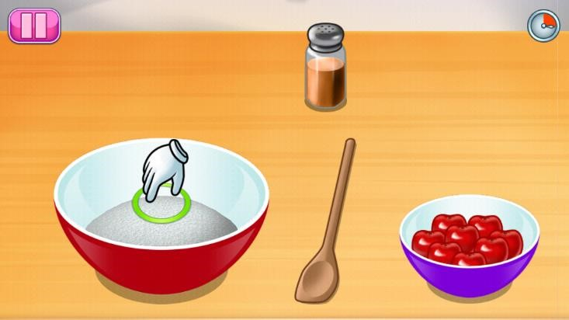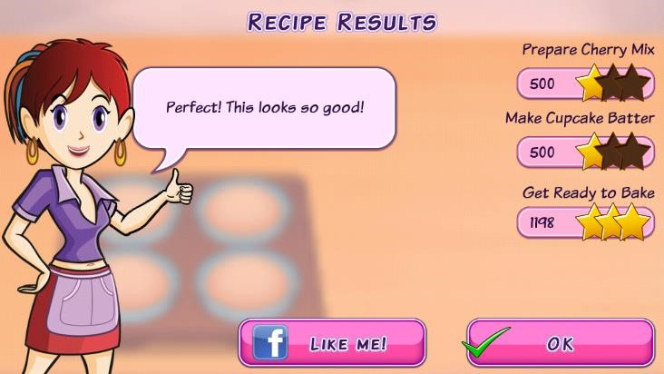

There is very little feedback which is

only seen after a stage of preparation

complete.

There

is

are

visual

prompts to describe each action,

which are easy

for users to follow.

The feedback does not seem to differ

depending on what grade was scored

for

each

stage

of

preparation.

Without feedback it is difficult to tell

what was not prepared well.

Lunch Food

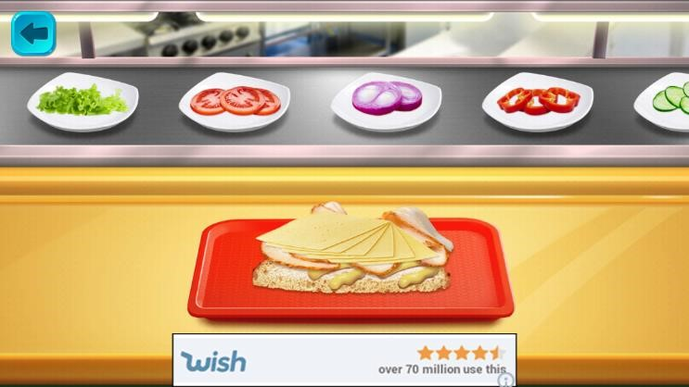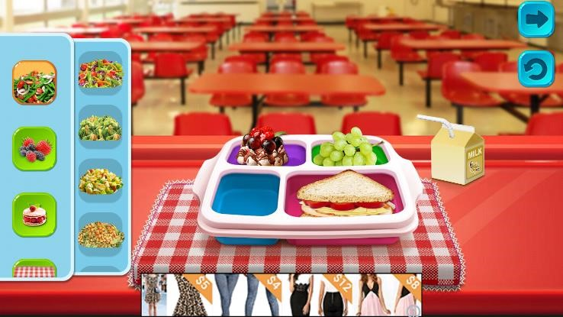

Both images show the various selections

players can use to cr

eate a meal, there is

no feedback and users must make

assumptions on how to interact with the

games environment. Although this game

lacks user friendliness its basic functions

are easy to use once informed.

Below is a comparison table of the similar products previously reviewed, this tabular view will help to visualise the information to make better comparisons. Each game simulates food preparation in different ways, but they all have some aspects of realism. Arguably all of the games can be considered to be an educational tool for teaching users new recipes, however I only listed “Cooking Mama” and “Sara Cooking” as it offers actual recipes to users. None of these games are serious games, although a case can be made for “Cooking Mama” as it covers simulation, education and frequent user feedback. The counter argument is that there is no distinct point, or problem that is trying to be addressed of fixed. Finally the feedback throughout each game varies drastically, as only “Cooking Mama” offers detailed hints, tips and post-game data for users to see.

|  |  |  |  |  |
| --- | --- | --- | --- | --- |
| **Attributes** | **Cooking Mama** | **Sara Cooking** | **Lunch Food** | **My Product** |
| **Simulation** | Yes | Yes | Yes | Yes |
| **Educational** | Yes | No | No | Yes |
| **Serious Game** | No | No | No | Yes |
| **Feedback Throughout Game** | Yes | No | No | Yes |

**Appendix C - Design Documentation Diagrams**

### Appendix D - Prototype Screen Shots

Entity Relationship Diagram

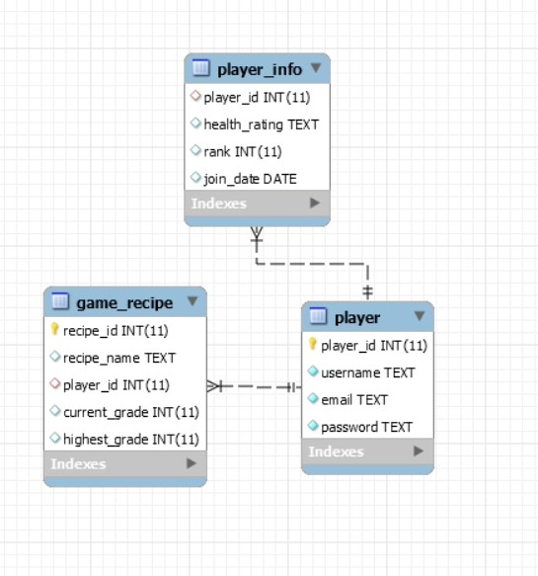

Use Case Diagram

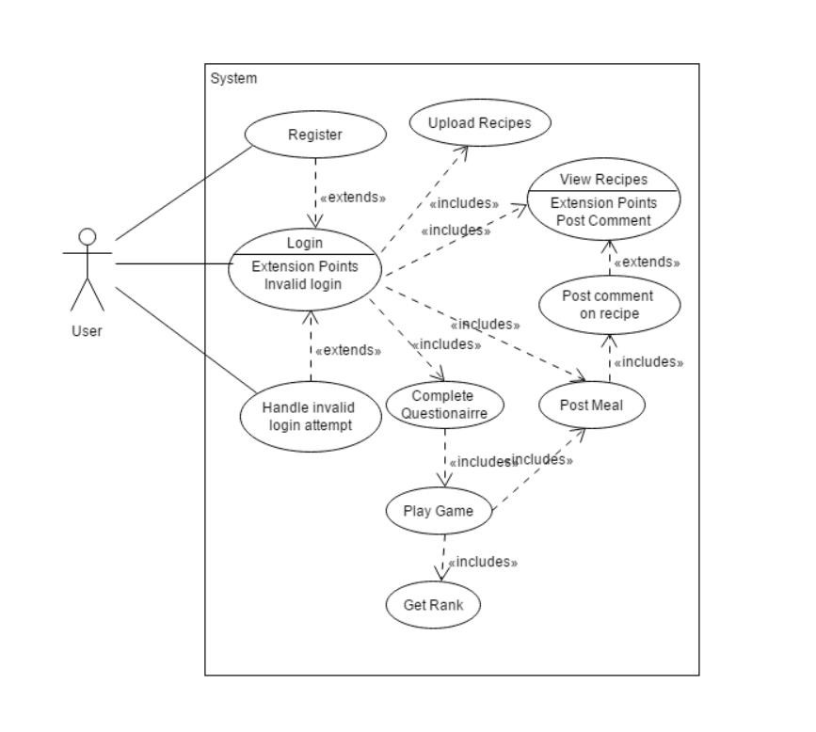

Class Diagram

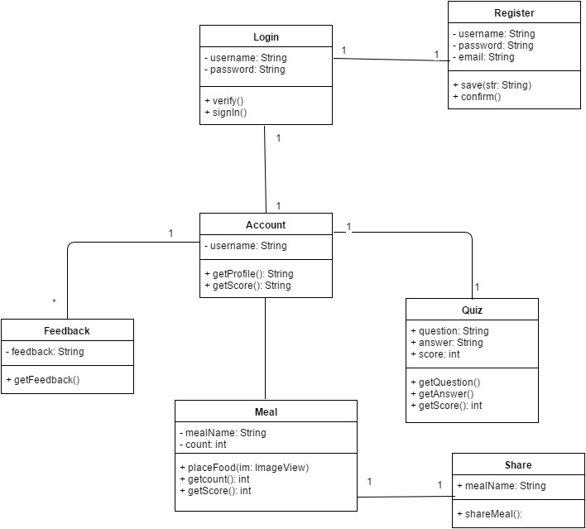

Decision Tree Part 1

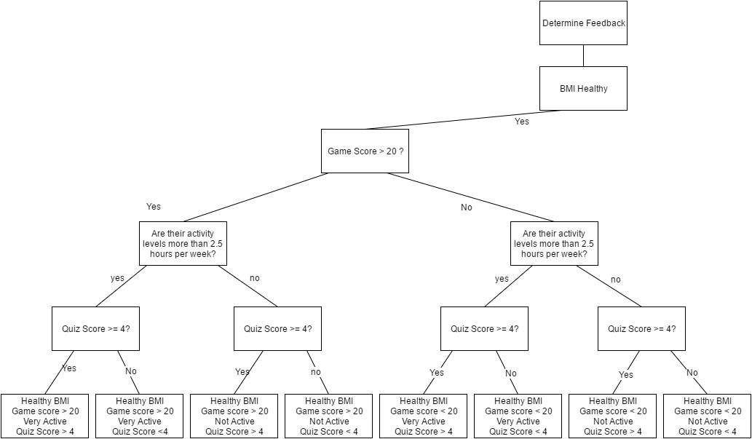

Decision Tree Part 2

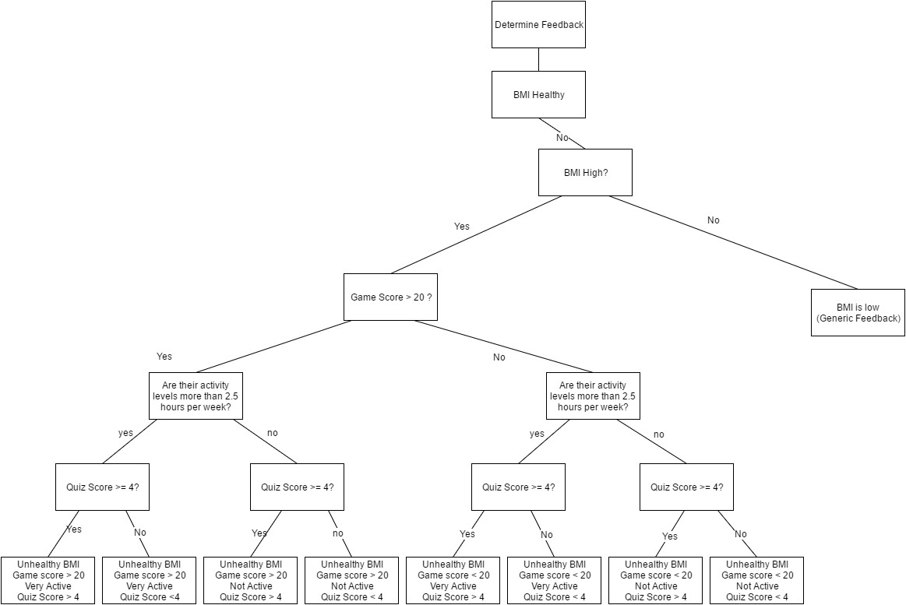

User Interface Designs

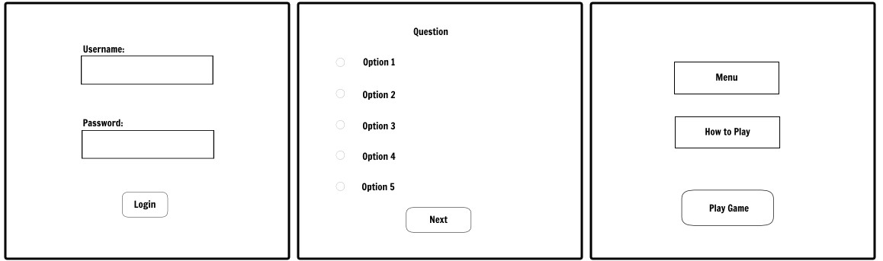

The above image shows three stages a user will encounter when using the application for the first time.

Image 1 (Left):

Login Page – allows user to authenticate after they register which will use a similarly formatted layout. Although there is no use of colour here the physical application will keep the same minimalist interfaces, keeping them simple to understand.

Image 2 (Middle):

Example survey page – user will read each question and answer as appropriate then move to the next page. It may be more efficient to have all questions on one page depending on the font type, size and toggle sizes.

Image 3 (Right):

Pre-game/pause page – user will be able to access menu options such as sound controls, account information and game instructions. Play button for game.

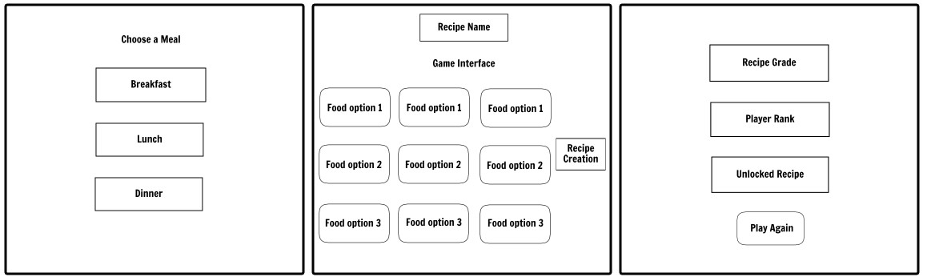

The above images reflect the intended game interface.

Image 1 (Left):

Choose a meal - Allows user to pick meals from a button or drop down box with more options.

Image 2 (Middle):

Game - The game interface is likely to change as it can be difficult to keep one vision for a product that is constantly developing. There is a very simple tap to select or drag and drop feature to create the desired meal.

Image 3 (Right):

Post-game page – user can see a grade for how healthy the meal they created was, they unlock a new healthy recipe and receive rank. Information can be gathered by pressing the relevant buttons.

### Appendix E - Evaluation Tables

|  |  |  |  |  |  |  |  |  |
| --- | --- | --- | --- | --- | --- | --- | --- | --- |
| Test case # | Test  Purpose | Source Code | | | |  | Pass/Fail | Corrective Action |
| 1 | Check “Enter” button takes user to get name class. |  | Button loginBtn =  (Button)findViewById(R.id.*login*);    loginBtn.setOnClickListener(  new Button.OnClickListener()  {  public void onClick(View v)  {  startActivity(new  Intent(MainActivity.this,  Login.class));  }  }); | | |  | Pass | N/A |
|  | | |
| 2 | Check quiz results are updated on button  click |  | if(f1.  == ans1 sco  } | |  | | --- | | isChecked | | () && qs1.getText()    "Correct! " + d1); |  | Pass | N/A |
| question1){  .setText( re++; |
| (code snippet) | | |
| 3 | Calculate Body mass index of user |  | bmi = (weight * 703) / (height * height); | | |  | Pass | N/A |
|  | | |

|  |  |  |  |  |  |  |
| --- | --- | --- | --- | --- | --- | --- |
| 4 | Assign Boolean values to variable if conditions are met |  | if(low.isChecked() ||  medium.isChecked()){    isActive = false;  }else if (high.isChecked()){  isActive = true;    } |  | Pass | N/A |
|  |
| 5 | Add ImageView to layout, keep running total of a value and assign a value to a counter |  | counter=1; score += 2;  placeFood(ribView); // odd |  | Pass | N/A |
| (code snippet) |
| 6 | Condition that finds whether an integer is odd or even |  | n++; if((n%2)==0){ |  | Pass | N/A |
|  |
| 7 | If statement which removes an Image View based on the value of a specified integer variable and subtracts a value based on its removal |  | theLayout.setVisibility(View.*GON*  *E*);  counter=0; score -= 2; |  | Fail | Method removeView  used instead of setting the ImageView  visibility |
|  |
| 8 | Method with view as parameter that places an ImageView based on met conditions. |  | public void  placeDrink(ImageView v){    if(dcounter == 1){ v.setX(1250);  v.setY(500); theLayout.addView(v,  params2);    }else{  textView.setText("You can only have 1 drink!");  }  } |  | Pass | N/A |
| 9 | Method with View as parameter that removes an  ImageView based on met conditions and |  | |  | | --- | | dcounter |   public void removeDrink(ImageView v){  =0;  theLayout.removeView(v);  } |  | Pass &  Fail | Successfully removes ImageView but integer value does not change.  Attempted to change where the value is |
|  |
|  | changes the value of variable |  | |  |  | called and assigned a new value. Value always stays at 0. No  fix |
| 10 | Creates a key-value pair of type integer and saves data to shared preferences  file |  | editor.putInt("key_gameScore", score);  editor.commit(); |  | Pass | N/A |
|  |
| 11 | Retrieves data previously saved in shared preferences file based on key name and value type |  | bmi = pref.getInt("key_bmi", 0); |  | Pass | N/A |
|  |

### Appendix F - Bibliography

Bogost, I. (2007) Serious Gaming. (video online) Available at: http://library.fora.tv/2009/06/17/Ian_Bogost_at_XMedia_Lab_Serious_Gaming (Accessed 16/10/2015)

Bogost speaks widely on serious games and how they have been used in current applications, and contrasting them with games that are not coined "serious" but give users a sense of purpose in the game. One of the games he says does that is Animal Crossing, pointing out that although it is for pure entertainment, you had the ability to purchase and sell goods and manage the amount of goods you own. He goes onto say his young son approached about the game and asked about managing goods and money. According to Bogost, this shows the aspect of games that can be used to inform people about serious issues. He also explained why he disagreed with the term "serious game" explaining that, even in other forms of media, serious issues can be addressed.

Sawyer, B. and Fiellin, E. (2013) Using Games to Improve Adolescent Health. (video online) Available at:

https://www.youtube.com/watch?v=FWT-CSlVuRA (Accessed 08/11/2015)

Sawyer speaks about some of the ongoing developments in serious games for health, and some of the concepts taken from well known video games and incorporated into their game so the users will have a connection to the product. Fiellin went on to describe the techniques used to develop a game made for children and teens that help them to make better decisions in regards to; relationships, sex and drugs and achohol. Fiellin explains, that the users of the product where a major part of of the development process so that they would be fully engaged in the finished product. She also mentions that changing behaviour and attitudes was the sole purpose of this game, which led her to speak about the evaluation process of the game to see how well, if at all, the game had worked.

Bergeron, Bryan. "Developing serious games (game development series)." Charles River Media (2006).

Drago-Severson, Eleanor, et al. "Three developmentally different types of learners." *Focus on Basics* 5.B (2001): 7-9.

Moore, Michael G. "Editorial: Three types of interaction." (1989): 1-7.

### Appendix G - Prototype Screen Shots

Prototype 1 Screenshots

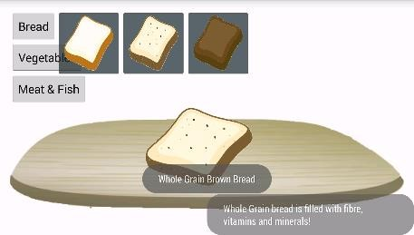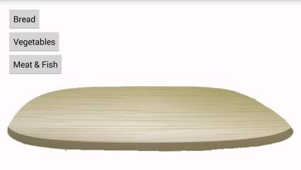

|  |  |  |  |
| --- | --- | --- | --- |
| |  | | --- | | Figure. 2, Very simple layout with chopping board image | | |  | | --- | | Figure. 3, Example of Toast which gives feedback (grey box) | |

|  |
| --- |
| Figure 4, Simplistic layout for questionnaire, made difficult to navigate by poor coding |

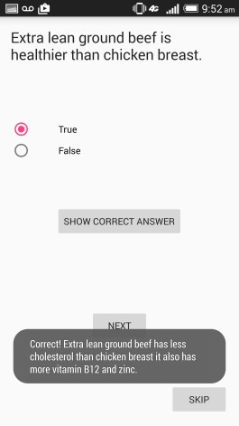

Prototype 3 – Screen shots

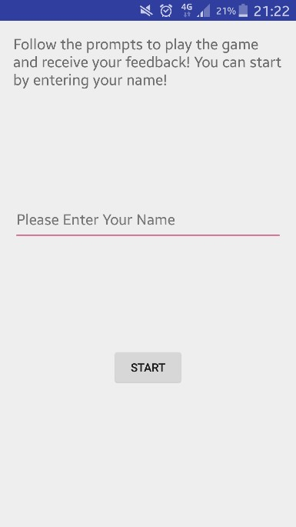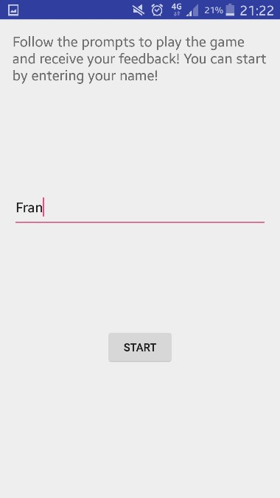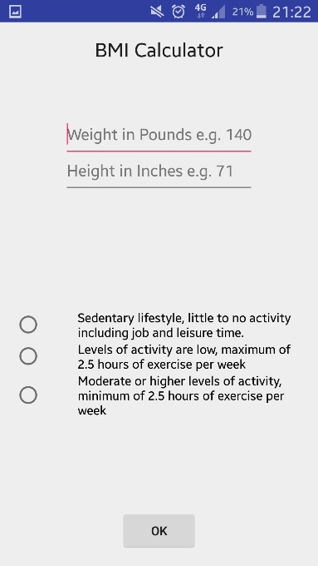

This is one of the helpful

prompts

that

is

found

throughout the game.

A user will input their name

in this text field which is then

used in the game.

The start button allows the

user to

proceed

to the

following page.

A user

has entered their name

here so they can proceed into

the game.

These areas are where a user

will enter their weight and

height in lbs and inches

respectively.

This

will

A user must make a selection on

how active

they are to influence

the feedback at the end of the

Another

button

which

submits the data into the

games shared preferences.

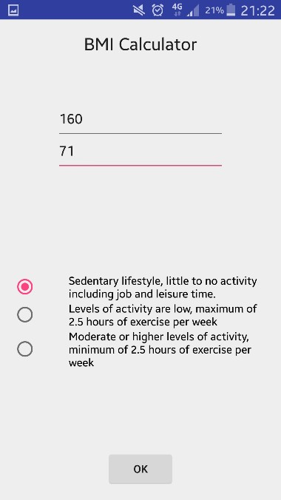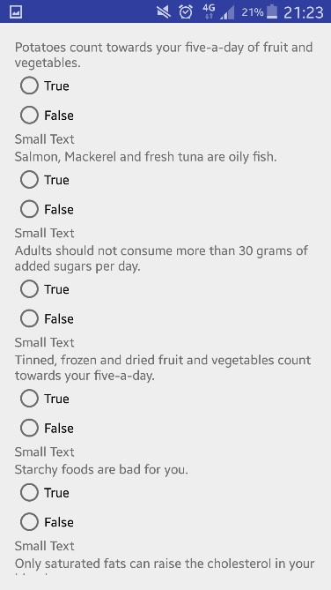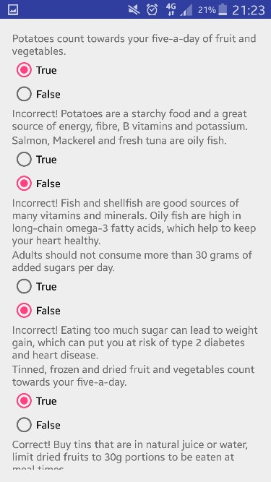

As you can see a user has

for

details

their

entered

feedback.

The q

uiz

section is shown here. A

number of questions are presented to

challenge the user’s knowledge of

healthy foods.

As you can see a user has completed

the quiz and

the correct answers are

displayed afterwards. A helpful

piece of information is

also given

after each question to improve the

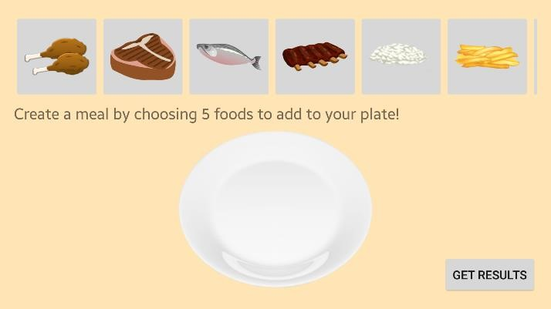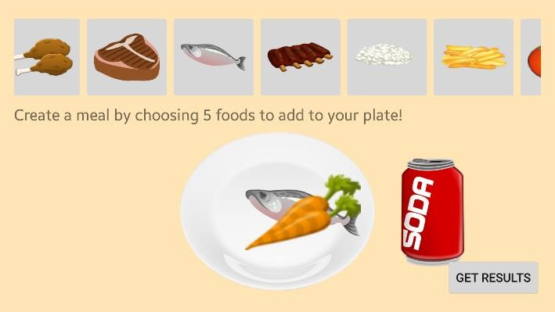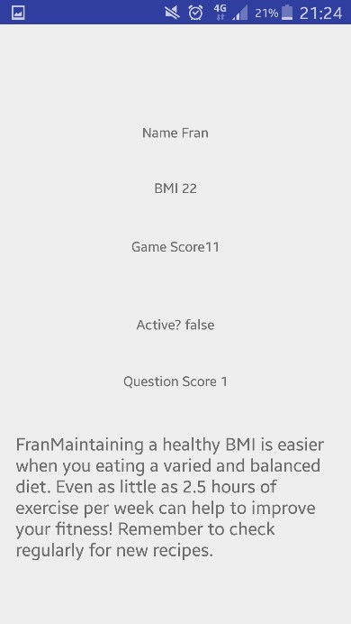

These buttons display

foods

and

different

drinks that a user can

select to make a meal.

The selections appear

here on the plate so that a

user

can

view

their

completed meal.

This button submits the

players selections which

is converted into a game

As you can see a player

has

completed

their

meal. One problem is

with the food placement.

This is the final feedback screen. All the users’

scores are displayed from each of the 4 sections.

BMI, Game Score, Activeness and Question

Score. All the scores form a user’s feedback and

a helpful tip is given at the bottom of the page.